**Task 9: Extended Response**

Comparison of Electric and Traditional Cars

Name: ­­_______________  
Teacher: ______________

Mark: ­­­­______  
Comment: __________________ _____________________________________________________________________________

**Assessment type:** Extended Response

**Conditions**

3 periods of research

1 period of validation-Friday 12th of August

**Task weighting**

10% of the school mark for this pair of units

6% for Assignment

4% for Validation

**Extended Response**

Context:

Since the introduction of the first electric car, the General Motors EV1, in 1996, electric cars have seen tremendous technological advances and a rise in popularity. The first viable electric car became available for purchase in 2008 with Tesla Motors. The Roadster was an all-electric vehicle using lithium-ion battery cells. Electric car sales in Australia only started to gain traction from 2011 onwards coinciding with electric car model availability.

Currently Australia has 3 million electric cars, with a predicted million more by the end of 2022.

Task:

A car dealership, who sells both electric and conventional vehicles, wants a brochure that clearly compares the two types of cars. They want a brochure that communicates the pros and cons of both types of vehicles to customers. As a knowledgeable scientist, you have been contracted to create this brochure for the dealership.

The dealership requires the brochure to have:

* Basic description of a conventional car: How do they work? What fuel do they use and where it is sourced? Where is energy wasted?
* Basic description of an electric car: How do they work? What fuel do they use and where it is sourced? Where is energy wasted?
* An energy diagram for both types of cars, showing what type of energy transformations occur and where these transformations take place.
* Comparison of environmental impact of both types of vehicles.
* Three pros and three cons for purchasing conventional vehicles
* Three pros and three cons for purchasing electric vehicles
* References for any information or images used in the brochure

Additional requirements:

* Brochure is to be no larger than A4 double sided
* 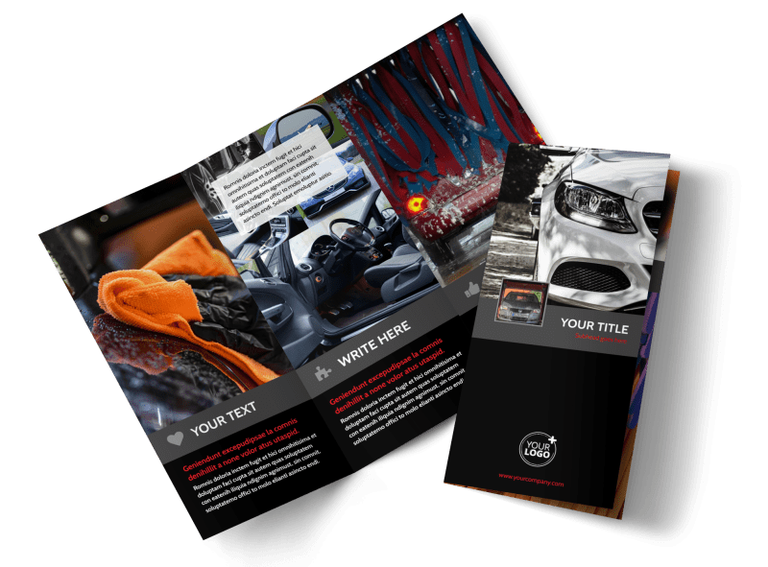Consider the target market; assume customers have no scientific knowledge of cars and engines
* Visually appealing and easy to read
* Unbiased: carefully select your sources and information
* Submitted to Connect or handed in as a hardcopy.

|  |  |  |  |  |  |  |
| --- | --- | --- | --- | --- | --- | --- |
| Student Name: |  | | |  | | |
| **Content/Scientific Merit** | **Acceptable Performance** | | | **Unacceptable Performance** | | |
|  | **Excellent (4)** | **Good (3)** | **Average (2)** | **Requires major improvement (1)** | | **Failed (0)** |
| **Basic description of a conventional car** | Accurately describes how conventional cars work. Accurately answers the questions: What fuel do they use and where it is sourced? Where is energy wasted? | Accurately describes how conventional cars work. Makes omissions when answering the questions: What fuel do they use and where it is sourced? Where is energy wasted? | Describes how conventional cars work with minor errors. Makes omissions when answering the questions: What fuel do they use and where it is sourced? Where is energy wasted? | Vaguely describes how conventional cars work and/or answers the additional questions. | | Omission or incorrect description |
| **Basic description of an electrical car** | Accurately describes how electric cars work. Accurately answers the questions: What fuel do they use and where it is sourced? Where is energy wasted? | Accurately describes how electric cars work. Makes omissions when answering the questions: What fuel do they use and where it is sourced? Where is energy wasted? | Describes how electric cars work with minor errors. Makes omissions when answering the questions: What fuel do they use and where it is sourced? Where is energy wasted? | Vaguely describes how conventional cars work and/or answers the additional questions. | | Omission or incorrect description |
| **Energy transformation diagram for conventional car** | Diagrams accurately shows how energy moves and changes form in a conventional car. All of the energy forms are labelled correctly. | Diagrams shows how energy moves and changes form in a conventional car with decent accuracy. Labelling of energy has 1 or 2 errors. | Diagram shows how the energy moves and changes form in a conventional car. Labelling of energy has 3 or 4 errors. | Diagram is extremely vague or confusing, or contain major errors or omissions. | | Diagram is missing or incorrect |
| **Energy transformation diagram for electrical car** | Diagrams accurately shows how energy moves and changes form in an electric car. All of the energy forms are labelled correctly. | Diagrams shows how energy moves and changes form in a conventional car with decent accuracy. Labelling of energy has 1 or 2 errors. | Diagram shows how the energy moves and changes form in a conventional car. Labelling of energy has 3 or 4 errors. | Diagram is extremely vague or confusing, or contain major errors or omissions. | | Diagram is missing or incorrect |
| **Comparison of environmental impact** | Accurately compares impact of producing and driving both types of vehicles and impact of fuel (sourcing and using). | Compares impact of producing and driving both types of vehicles and impact of fuel (sourcing and using). Minor omissions or errors. | Compares impact of producing and driving both types of vehicles and impact of fuel (sourcing and using). Major omission or error. | Incorrectly compares environmental impact or omits major pieces of information. | | No attempt is made OR the attempt is vague, incorrect or inappropriate |
| **Conventional: Pros and Cons** | Six reasonable pros and cons, **clearly explained**, included in presentation. | Five reasonable pros and cons, **clearly explained**, included in presentation. One omitted, incorrect or not clearly explained. | Four or three reasonable pros and cons, **clearly explained**, included in presentation. Others omitted, incorrect or not clearly explained. | Two or one reasonable pros and cons, **clearly explained**, included in presentation. Others omitted, incorrect or not clearly explained. | | No attempt is made OR the attempt is vague, incorrect or inappropriate |
| **Electrical: Pros and Cons** | Six reasonable pros and cons, **clearly explained**, included in presentation. | Five reasonable pros and cons, **clearly explained**, included in presentation. One omitted, incorrect or not clearly explained. | Four or three reasonable pros and cons, **clearly explained**, included in presentation. Others omitted, incorrect or not clearly explained. | Two or one reasonable pros and cons, **clearly explained**, included in presentation. Others omitted, incorrect or not clearly explained. | | No attempt is made OR the attempt is vague, incorrect or inappropriate |
|  | | | | | | |
| **Presentation Merit** | **Acceptable Performance** | | | **Unacceptable Performance** | | |
|  | **Excellent(4)** | **Good(3)** | **Average(2)** | **Requires Major Improvement(1)** | **Failed(0)** | |
| **Appearance & Layout** | Information is presented in a logical, interesting sequence that the reader can follow. Font usage, use of colour and overall appearance of presentation is aesthetically pleasing | Minor errors in sequencing: enough to notice, but not major distraction,. Minor error and/or omission with appearance (font size/usage, colour etc) | Multiple minor errors in sequencing: enough to be noticeable and distracting to audience. Multiple minor errors and/or omissions OR a major error or omission with appearance. | Major errors in sequencing or in overall appearance | No logical sequence to presentation. Font usage, usage, colour, or overall appearance is distracting to audience. | |
| **Graphics or images** | Use of four or more graphics explains reinforces text and presentation. | Minor error and/or omission with use of graphics (missing an explanation or 3 graphics included | Multiple minor errors and/or omissions OR a major error or omission with use of graphics | Major errors with use of graphics | Graphics missing or are superfluous to presentation. | |
| **Use of English** | Correct use of English language (spelling, grammar, punctuation) throughout the presentation | Minor error and/or omission during presentation. | Multiple minor errors and/or omissions OR a major error or omission with use of graphics | Several minor mistakes OR major errors in use of English | Multiple minor errors in use of English | |
| **Language accessible to all** | Brochure explained all concepts in language that suited target audience | Brochure explained most concepts in language that suited target audience | Brochure explained some concepts in language that suited target audience | Brochure attempted to explain concepts in language that suited target audience | Brochure did not attempt to explain concepts in language that suited target audience | |